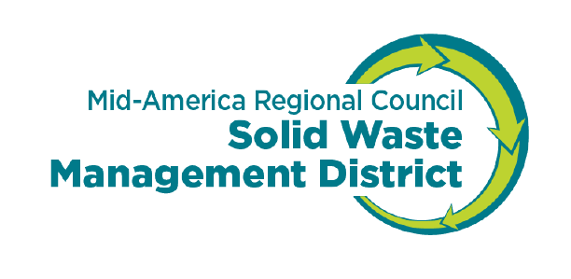

FINAL REPORT FORM

Recipients of MARC Solid Waste Management District grant funds are required to submit a final report of the project. Final reports are due 15 days after the close of the project and are required for the applicant to receive final payment.

Complete and return to:
Nadja Karpilow at karpilow@marc.org
Please remember to sign and date the report

Project #: _____________ Project Manager: __________________________________________________________

Project Name: _____________________________________________________________________________________

- Describe the project goals. How do the results of the project compare with the stated goals in the application?

- What was the total solid waste diversion over the project period and how much do you expect to divert in the next twelve-month period?

- Describe the factors that either allowed or prevented achievement of project goals and objectives set forth in the approved agreement.

- What were the results of your evaluation procedures?

- Describe both positive and negative lessons learned from the project.

- If you were to attempt this project again, what information would you want to know at the beginning of the project and what would you do differently to obtain better results?

- Discuss the benefits derived by your agency in receiving this grant and whether it is economically feasible for your agency to continue with this project.

- Indicate the number of new jobs created as a result of your project.

- How much revenue was generated during the project period as a result of the grant funds, both gross and net?

- Are there any other comments you would like to share?

Signature of Authorized Official_____________________________________________ Date_________________

Updated December 2024

