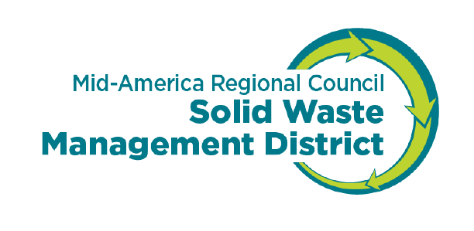
Bidding/Quotes Table
- Items $10,000 up to $99,999 require three quotes.
- Budget items $100,000 or more require advertising in two daily newspapers
- Shipping costs are included in value of item
- Strive to include MBE and WBE. For a list go to http://oeo.mo.gov/ Definition: - a business that is a sole proprietorship, partnership, join venture , or corporation in which at least 51% of the ownership interest is held by minorities or women and the management and daily business operations of which are controlled by one or more minorities or women who own it.

Item/Service: | Vendor  Include name and address | Method (phone call, e-mail, advertisement, website) | Cost Estimate
Amount Budgeted:  $________________ | 1.
Specifications, and due date for bids if advertised: | 2.
 | 3.
 | 4.

Vendor | Evaluation of Vendor and Product/Services
1.

2.

3.

4.

Attach proof of advertising if applicable, and copies of bid responses or quotes.

