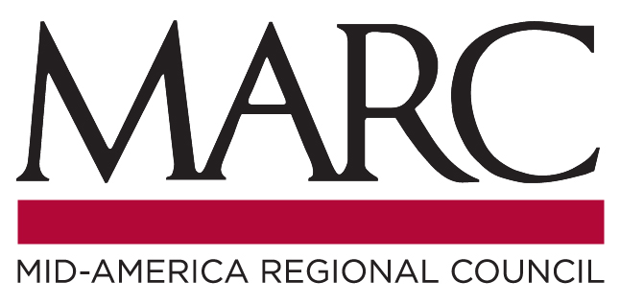
Travel Model Users Group

There will be a meeting of the Travel Model Users Group
Thursday, April 20, 2023, at 1:30 pm
Mid-America Regional Council, Westview, 2nd Floor
Rivergate Building, 600 Broadway, Kansas City, Missouri

Agenda

- Welcome & Introductions
- MARC Model Update:
- MARC Travel Demand Forecast Model Version19 (Cambridge Systematic Jason Lemp)
- KC Streetcar Northrail Extension Study (Kimley-Horn, Anthony Gallo)
- Use of MARC model for future forecasts and STOPS modeling/ridership forecasting
- Open Discussion (Topics include Scenario Planning, Induced VMT, City model development and MARC model extension, etc.)
- Other Business
- Adjourn

Parking: Free parking is available when visiting MARC. Visitors and guests should park on the upper level of the garage. An entrance directly into the conference area is available from this level. To enter this level from Broadway, turn west into the Rivergate Center parking lot. Please use any of the available spaces on the upper level at the top of the ramp

Getting to MARC: For information on transportation options to the MARC offices, including directions, parking, transit, carpooling, and bicycling, visit http://marc.org/mapandparking.htm.

Special Accommodations: Please notify the Mid-America Regional Council at (816) 474-4240 at least 48 hours in advance if you require special accommodations to attend this meeting (i.e., qualified interpreter, large print, reader, hearing assistance). We will make every effort to meet reasonable requests. MARC programs do not discriminate against anyone on the basis of race, color or national origin, according to Title VI of the Civil Rights Act of 1964. For more information or to obtain a Title VI Complaint Form, see http://www.marc.org/transportation/title_vi.htm or call 816-474-4240.

